**Assignment 03 (Organizational Structure)**

**Name:** Muhammad Fahad

**ID:** FA19-BSSE-0014

**Course:** Principle of Management

**Section:** EM

**Teacher:** Uzma khan

# **Facebook**

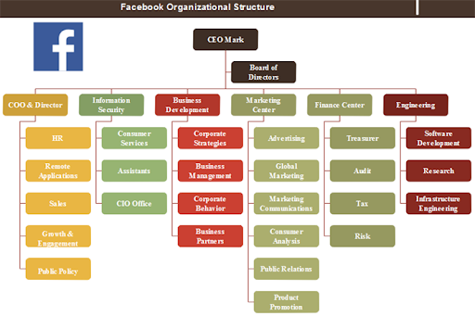

## **Structure:**

**Function base** Structure (according to the chart).

## **Explanation:**

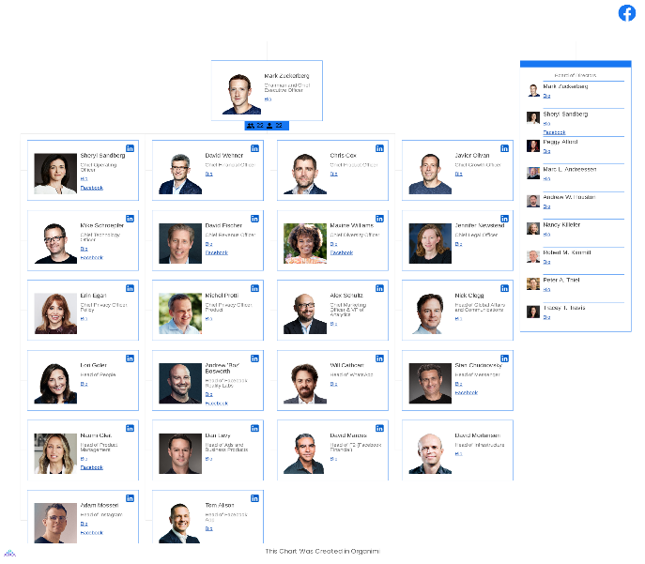 Facebook according to the chart is organized by functional team to get the maximum expert in a single window to increase the work efficiency. Facebook also used **Matrix Org structure**: unlike most large organizations, Facebook uses a matrix org structure. The key characteristics of the matrix structure help to facilitate the needs of tech-orientated companies like Facebook creativity, innovation, and the scope to expand and diversify.